**Name:**______________________________

**Marks: 53**

* **Instructions:**
  + You will be given **1 hour and 50 minutes** to complete the exam.
  + The exam two parts.
  + You must open Camera on MS Team all the exam time.
  + Questions are based on the ICCC database: Content-> Course Resources -> Databases-> Ivy Covered Community College (ICCC) Database.
  + Set echo, linesize, and pagesize at the beginning of SQL script file.
  + Use appropriate column headings and formatting, if not mention.
  + Do not put your query on ONE line, distribute it in suitable lines.
  + Relax - you know this material.
* **Submission:** 
  + **For Part A**, submit ONE file containing your SQL code for all questions and another spool file containing the commands with the resultant output for all 7 questions.
  + **For Part B**, submit a separate SQL script used to produce the report and a spool file containing the results.

## **Part A: Queries**

You can use the COLUMN … FORMAT … command to limit the width and format of your columns (if required). Do a CLEAR COLUMNS after the query to clear out the column width settings.

**Question 1 (5 points)**

Show the highest number of students in a program of studies. Assign alias “Highest No. of Students” for the result.

**Question 2 (5 points)**

Show all employees who have Unit number. Include the following with the same order:

1. employee ID with alias “EmpID”,
2. surname and first name formatted as "surname, first name" with alias “Name”,
3. seniority date formatted as “Month DD, YYYY” with alias “Seniority”, and
4. unit number.

Sort by “Name” in a descending order.

**Question 3 (5 points)**

Show all students who was born in March. Include surname, first name, and birth date with alias “Date”. Format the birth date as MAR 31,1995. Sort by surname and then first name.

**Question 4 (5 points)**

Show the average grade of students in the course “CMPP230” and assign alias “Average” for the result. The output is formatted to only include two digits of precision.

**Question 5 (5 points)**

Show all faculty members who have at least 2 expertise levels. Include first name, surname, and the number of expertise levels. Sort by first name and then surname.

**Question 6 (8 points)**

Show all faculty members who have the minimum salary in their units. Include surname as “Last”, first name as “First”, seniority date as “Seniority”, unit as “Unit”, and salary as “Salary”. Don’t include faculty member who have not been assigned to a unit yet. Sort by salary in a descending order.

**Question 7 (10 points)**

Display all faculty members whose salary is below the average salary in the faculty. Include first name as “First Name”, surname as “Last Name”, unit as “Unit”, and salary “Salary”. Format the salary as $49,000. If the faculty member has not been assigned to a unit yet, substitute 0 in a unit. Sort by salary in a descending order.

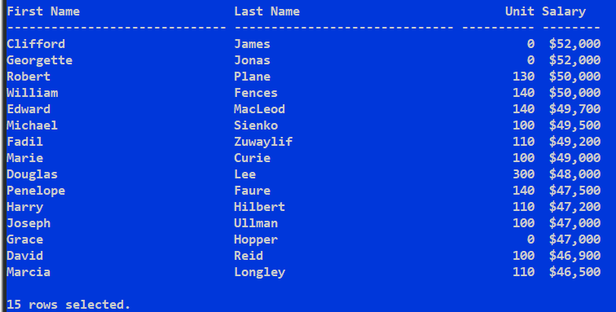

## **Part B: Report**

**Question 1 (10 points)**

Generate a report of all the faculty members whose unique expertise level is greater than or equal 7. Sort by expertise level and faculty ID. The output should match what is shown below. Make the report width 80 characters wide.

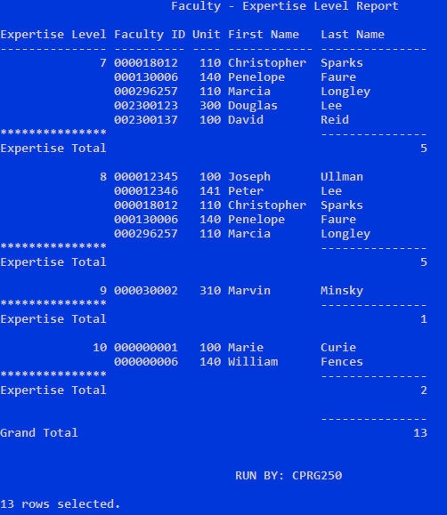

***Best wishes***